The Bureau of Dog Law Enforcement will be conducting a license canvass in Lancaster County on May 24th. Multiple wardens will be going door to door educating dog owners as well as checking the status of their dog licenses and rabies vaccinations.
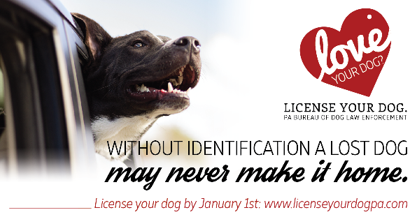
Your best friend’s best chance to make it home safely is to be properly licensed.
All dogs 3 months of age or older
Are required by Pennsylvania law to have a current dog license.
Failure to have your dog licensed may result in a fine of up to $300 (per dog).

How much does a license cost?
How do I get a Dog License?
Annual license fees are as follows:
In Lancaster County, you can obtain a dog license by contacting:
Amber Green
Lancaster County Treasurer
150 N. Queen Street, Suite 122 Lancaster, PA 17608
717-299-8222
General:
Dogs that are spayed or neutered $6.50
Dogs not spayed or neutered $8.50
Senior citizens (65 years of age and older)
or persons with proof of disability:
Dogs that are spayed or neutered $4.50
Dogs not spayed or neutered $6.50
For more information, contact the Pennsylvania Department of Agriculture at 717.787.3062
You may also contact, Lancaster County State Dog Warden, Travis Hess at 717-805-3442



